**OOP_HW00_109000000**

**蔡大頭**

**Part 1：Installation result**

//Screenshot your result after trying Google Test

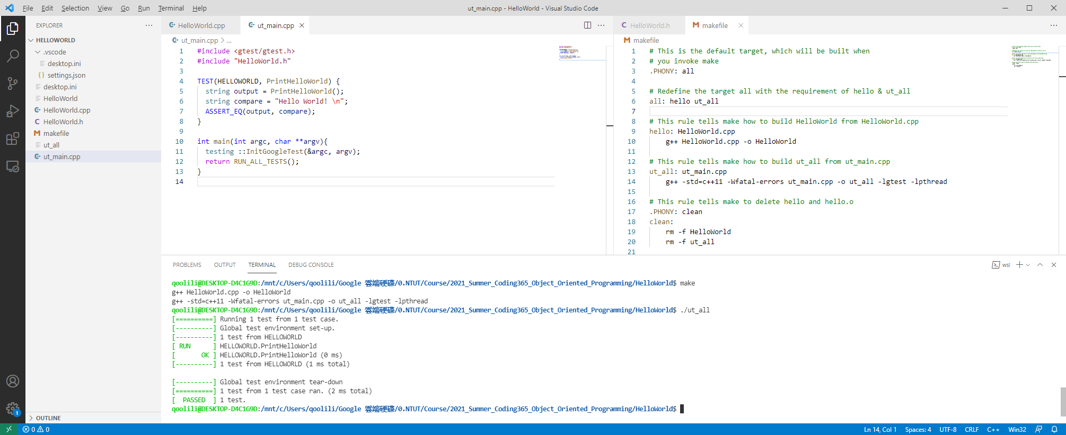

**Format Guide**:

1. Content format: should be set with 16pt row height, align to the left, font size 12pt.
2. Caption format: 18pt and Bold font.
3. Font format: Times New Roman.
4. Figure: center with single line row height.
5. Change the title to your student ID and name in Chinese. If you don‘t has ID, just leave it blank.
6. Upload pdf file with the file name format : **OOP_HW00_109000000.pdf** (change to your student ID) If you don‘t has ID, fill your name instead.
7. Remove the line starting with //.
8. Remove format guide part before uploading.